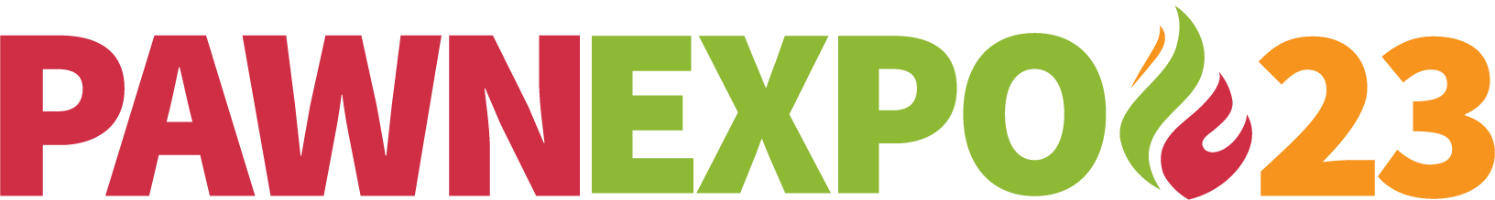

Use this checklist to assist you in preparing for Pawn Expo
_____ Submit Booth Application and Contract
_____ Pay balance in full by February 26,2023
_____ Consider Pawn Expo 2023 sponsorship opportunities (available only to exhibitors)
_____ Book Industry Insight if interested, for July 17 ($850 for members)
_____ Visit Exhibitor Resource Section for A-Z answers about booth logistics
_____ Please re-read Convention Rules and Regulations (*pages 28-36 updated since 2022)
_____ Make hotel reservations through PawnExpo.com – Pawn Expo rate available until June 1, 2023
_____ Book airline tickets and/or arrange transportation to Cobb Galleria Center Atlanta
_____ Submit certificate of insurance – Due no later than May 1, 2023
_____ Register your complimentary attendees at PawnExpo.com, by July 1, 2023
_____ Look at quick facts for information about what is included with booth, hours, shipping addresses, and contacts
_____ Review the RPMXPO On-line ordering expo kit to arrange shipments and order booth related items. Early Bird ordering ends Jun 16, 2023.
_____ Do not forget to order electricity, Internet and AV from Cobb Galleria Centre directly
_____ Shipments to arrive at RPMXPO warehouse earliest June 23 until last day July 7, 2023. Shipping labels included in expo kit.
_____ Mobile App will be downloadable in June 2023

SHOW SCHEDULE
- Monday July 17 conference day, GIA training, Jewelry Exchange 1-6:30pm, Industry Insights 12-6pm, Welcome Mixer 5-6pm
- Tuesday July 18 Conference Day, Exhibitor Set-up 8:30-6pm, Jewelry Exchange 9am-12pm, 7pm NPA Gala and auction
- Wednesday July 19 Exhibit Hall open 10:30-6pm, Vendor Love reception 5-6pm, Atlanta Braves game 7pm
- Thursday July 20 Exhibit Hall 9-1:30pm. All booths must be staffed until close. All exhibits must be packed by 5:30pm.

For any questions about booth logistics and registration contact Veronica@nationalpawnbrokers.org

For Sponsorships and marketing contact Jody@nationalpawnbrokers.org

